Stability-Guided Ensemble Pruning for Binary Medical Classification
Course: CS1-0110 Introduction to Machine Learning / ELE461 Machine Learning
Instructor: Dr. Haneen Altartouri — Fujairah University, College of Engineering and Technology
Spring Semester, AY 2025–2026
Author(s): [Baraa Ahmad, Abdalla Khalifa, Saif Mustafa] Student ID: [F202210176, F202310087, F202310108]

Abstract
Ensembles of heterogeneous classifiers often improve generalization, but naively combining all available models can dilute predictive power with unstable or weak learners. This paper investigates a stability-guided ensemble pruning strategy in which base classifiers are first ranked by their cross-validated mean and variance of ROC-AUC and then pruned before forming a soft-voting or weighted-voting ensemble. Using two public binary medical classification datasets — UCI Heart Disease (n = 303) and Pima Indians Diabetes (n = 768) — we evaluate five base classifiers (Logistic Regression, SVM, k-Nearest Neighbors, Random Forest, and XGBoost) with 5×5 Repeated Stratified K-Fold cross-validation over eight metrics. Two pruning strategies (mean- and median-thresholded) are compared against full soft-voting, stacking, stability-weighted voting, and an α-weighted performance/stability tradeoff. Across both datasets the pruned ensembles matched or outperformed the full ensembles, with the largest gains observed on Pima Diabetes where stability-guided pruning raised ROC-AUC from 0.835 (full soft voting) to 0.843 and MCC from 0.484 to 0.510. On Heart Disease, all ensemble methods converged to a near-identical ceiling (AUC ≈ 0.91), but pruned variants achieved this with lower variance across folds. The results support the hypothesis that selecting a small, stable subset of strong learners produces ensembles that are at least as accurate as full ensembles while being simpler and more robust.

1. Introduction
Machine learning is increasingly used to support clinical decision-making, where the cost of an incorrect prediction can be high and datasets are typically small, imbalanced, and noisy. In this setting, ensemble learning — combining the predictions of several base learners — is an attractive strategy because it can reduce variance and improve generalization compared to any single classifier. However, ensemble performance is not monotonic in the number of models: including unstable or weak learners can harm the aggregated prediction and increase computational cost.
This project investigates whether it is beneficial to first evaluate the stability of individual base learners — measured by the mean and variance of their cross-validated ROC-AUC — and then prune the ensemble to retain only the most reliable ones before performing any hyperparameter tuning. The motivation is two-fold: (i) pruning unstable models removes a source of noise from the voting process, and (ii) tuning after pruning avoids the selection bias that would arise if an over-tuned but structurally weak model were allowed into the final ensemble.
The specific research questions addressed are:
- RQ1: Does stability-guided pruning improve the performance of soft-voting ensembles compared to using all base classifiers?
- RQ2: How do mean- and median-based thresholding strategies compare as pruning criteria?
- RQ3: Is explicit stability-aware weighting (weighted voting, α-weighted voting) preferable to simple pruning?
- RQ4: Does hyperparameter tuning applied after pruning add measurable value on top of the pruning step?

2. Dataset Description
Two publicly available binary medical classification datasets were used. Both are standard benchmarks in the ML literature and present complementary challenges for preprocessing and modeling.

2.1 UCI Heart Disease (id = 45)
The Cleveland Heart Disease dataset consists of 303 patient records and 13 clinical features (age, sex, chest-pain type, resting blood pressure, serum cholesterol, fasting blood sugar, resting electrocardiographic results, maximum heart rate achieved, exercise-induced angina, ST depression, slope of the peak exercise ST segment, number of major vessels colored by fluoroscopy, and thalassemia). The original target variable encodes disease severity on a 0–4 scale and is binarized in this study: 0 = no disease, any value > 0 = disease. After binarization the classes are roughly balanced (approximately 54 % negatives to 46 % positives). A small number of features contain missing values, which are handled inside the cross-validation pipeline using median imputation.

2.2 Pima Indians Diabetes
The Pima Indians Diabetes dataset contains 768 female patients of Pima heritage, aged 21 and older, with 8 clinical features (number of pregnancies, glucose, blood pressure, skin thickness, insulin, BMI, diabetes pedigree function, and age). The binary target indicates whether the patient was diagnosed with diabetes within five years of the measurement. The dataset presents two well-known preprocessing difficulties: (i) moderate class imbalance, with approximately 35 % positives, and (ii) zero-encoded missing values in Glucose, BloodPressure, SkinThickness, Insulin, and BMI. These zeros are physiologically implausible and are replaced with NaN before passing the data into the cross-validation pipeline, which uses iterative imputation, standard scaling, and SMOTE oversampling inside each training fold.

3. Methodology

3.1 Experimental Framework
All experiments were implemented in Python using scikit-learn, imbalanced-learn, and XGBoost. The evaluation protocol uses RepeatedStratifiedKFold with 5 splits and 5 repeats, yielding 25 out-of-fold estimates per metric per model. A fixed random seed (42) was used throughout for reproducibility. All preprocessing steps — imputation, scaling, and, for Pima, SMOTE — are wrapped inside scikit-learn or imbalanced-learn Pipeline objects so that they are fitted only on the training fold, eliminating data leakage.

3.2 Base Classifiers
Five heterogeneous base classifiers were evaluated, deliberately covering linear, margin-based, instance-based, bagging, and boosting families: Logistic Regression (LR), Support Vector Machine with RBF kernel (SVM), k-Nearest Neighbors (kNN), Random Forest (RF), and XGBoost. All classifiers use their default hyperparameters during the stability evaluation stage; hyperparameter tuning is intentionally deferred to a later stage to avoid biasing the pruning decision in favor of models that happen to respond well to the specific grid considered.

3.3 Evaluation Metrics
Eight metrics are computed per fold: Accuracy, Recall (Sensitivity), Precision, Specificity, weighted F1, ROC-AUC, PR-AUC (average precision), and the Matthews Correlation Coefficient (MCC). Specificity and MCC are implemented as custom scorers since they are not provided by default in scikit-learn.

3.4 Stability Score
Following the intuition that a good ensemble member should be both strong and consistent, we define the stability score of a model as
Stability Score = Mean ROC-AUC / ( Std ROC-AUC + ε )
where ε = 1e–9 avoids division by zero. A high stability score indicates a model that is both accurate on average and consistent across folds.

3.5 Pruning Strategies
Two pruning strategies are compared. Both require a model to satisfy two conditions simultaneously: Mean AUC ≥ τ_mean and Std AUC ≤ τ_std. The thresholds are computed from the pool of all base classifiers:
- Mean-based: τ_mean = mean of all models' Mean AUC; τ_std = mean of all models' Std AUC.
- Median-based: τ_mean and τ_std are the medians instead of the means.
If fewer than two models satisfy the criterion, the thresholds are relaxed incrementally until at least two classifiers are selected, guaranteeing that the resulting ensemble is well-defined.

3.6 Ensemble Methods Compared
Six ensemble methods are compared against the five individual base classifiers:
- Full Soft Voting — probability averaging over all five models.
- Full Stacking — five base models with Logistic Regression as the meta-learner.
- Pruned Ensemble (Mean Threshold) — soft voting over the mean-thresholded subset.
- Pruned Ensemble (Median Threshold) — soft voting over the median-thresholded subset.
- Weighted Voting — soft voting with weights proportional to stability scores, both over all five models and over the median-pruned subset.
- α-Weighted Voting — weights computed as W = α × MeanAUC_norm + (1 − α) × (1 − StdAUC_norm) with α = 0.7, recomputed per fold.

3.7 Hyperparameter Tuning
After pruning, GridSearchCV (cv = 3) is applied only to the classifiers that were selected by each pruning strategy. The tuned versions are then re-evaluated with the same 5×5 repeated cross-validation protocol, producing two additional rows in the final comparison table: “Pruned Ensemble (Mean Threshold, Tuned)” and “Pruned Ensemble (Median Threshold, Tuned)”.

4. Experiments and Results

4.1 Stage 1 — Stability Evaluation
Table 1 summarizes the stability evaluation of the five base classifiers on both datasets. Each value is the mean across 25 folds. Stability Score captures both magnitude and consistency of ROC-AUC.
Table 1. Stability evaluation of base classifiers (5 × 5 Repeated Stratified K-Fold).
Dataset | Model | Mean AUC | Std AUC | Mean MCC | Stability Score
Heart | LR | 0.9059 | 0.0391 | 0.6766 | 23.18
Heart | SVM | 0.8990 | 0.0378 | 0.6690 | 23.77
Heart | kNN | 0.8907 | 0.0387 | 0.6596 | 23.01
Heart | RF | 0.9047 | 0.0369 | 0.6644 | 24.49
Heart | XGBoost | 0.8787 | 0.0358 | 0.6076 | 24.57
Pima | LR | 0.8366 | 0.0310 | 0.4843 | 26.97
Pima | SVM | 0.8258 | 0.0290 | 0.4792 | 28.45
Pima | kNN | 0.7802 | 0.0394 | 0.4205 | 19.81
Pima | RF | 0.8258 | 0.0324 | 0.4726 | 25.47
Pima | XGBoost | 0.8008 | 0.0308 | 0.4340 | 26.01

On Heart Disease, LR and RF dominate on mean AUC while XGBoost is comparatively weak. On Pima, LR is the strongest individual model and kNN is clearly the weakest. Importantly, the stability scores rank the models differently from the raw mean AUC — XGBoost has the highest stability score on Heart despite the lowest mean AUC because its variance is the smallest. This illustrates why stability, rather than accuracy alone, is a sensible filter: a consistent but mediocre classifier may still be harmful in an ensemble if it systematically votes against stronger members.
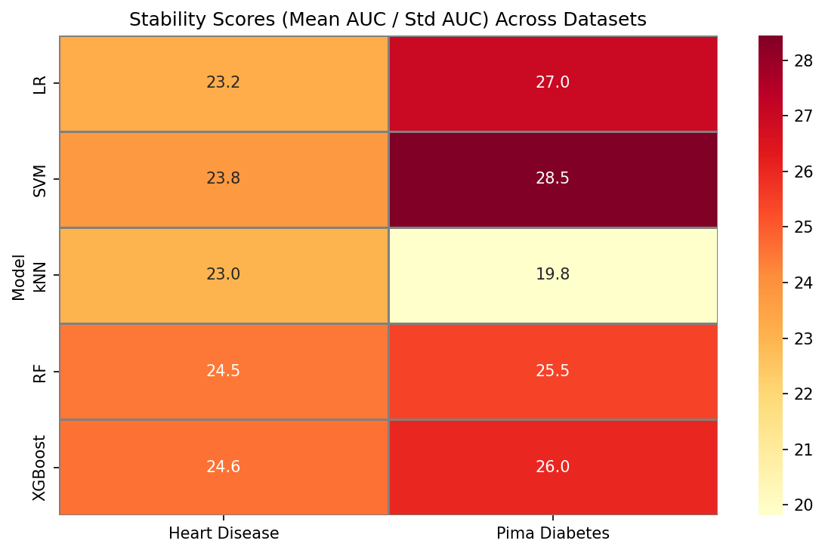
Figure 1. Stability Score heatmap for the five base classifiers on both datasets.

4.2 Stage 2 — Pruning Outcome
Applying the mean-based criterion (Mean AUC ≥ mean, Std AUC ≤ mean) yields the following selected subsets:
- Heart Disease: LR, SVM, Random Forest — XGBoost and kNN are pruned because their mean AUCs fall below the pool average.
- Pima Diabetes: LR, SVM, Random Forest — kNN and XGBoost are pruned; kNN has both the lowest mean AUC and the highest variance on this dataset.
The median-based strategy produced similar subsets in both datasets, reflecting the relatively symmetric distribution of base-model AUCs in this experiment. Where the two strategies coincide, the median-pruned voting ensemble shares the same members as the mean-pruned one but uses stability-score weights in the weighted-voting variant.

4.3 Stage 3 — Method Comparison
Tables 2 and 3 report the full performance comparison across all evaluated methods on Heart Disease and Pima Diabetes respectively. Each entry is the mean across 25 folds; the strongest value in each column is in bold in the narrative text but the tables report numerical values to four decimal places.
Table 2. Method comparison on UCI Heart Disease (mean of 25 folds).
Method | Acc | Recall | Spec. | F1 | AUC | PR-AUC | MCC
LR (default) | 0.8375 | 0.7914 | 0.8769 | 0.8365 | 0.9059 | 0.9040 | 0.6766
SVM (default) | 0.8342 | 0.7783 | 0.8818 | 0.8331 | 0.8990 | 0.8973 | 0.6690
kNN (default) | 0.8303 | 0.7885 | 0.8659 | 0.8295 | 0.8907 | 0.8578 | 0.6596
RF (default) | 0.8315 | 0.7769 | 0.8780 | 0.8302 | 0.9047 | 0.8985 | 0.6644
XGBoost (default) | 0.8038 | 0.7639 | 0.8377 | 0.8027 | 0.8787 | 0.8741 | 0.6076
Full Soft Voting | 0.8322 | 0.7854 | 0.8720 | 0.8312 | 0.9096 | 0.9083 | 0.6654
Full Stacking | 0.8368 | 0.7898 | 0.8769 | 0.8359 | 0.9097 | 0.9086 | 0.6743
Pruned (Mean) | 0.8342 | 0.7883 | 0.8733 | 0.8333 | 0.9101 | 0.9063 | 0.6689
Pruned (Mean, Tuned) | 0.8388 | 0.7814 | 0.8879 | 0.8377 | 0.9100 | 0.9093 | 0.6783
Pruned (Median) | 0.8375 | 0.7840 | 0.8830 | 0.8363 | 0.9083 | 0.9058 | 0.6763
Pruned (Median, Tuned) | 0.8335 | 0.7841 | 0.8758 | 0.8326 | 0.9092 | 0.9063 | 0.6674
Weighted Voting (All) | 0.8309 | 0.7826 | 0.8720 | 0.8299 | 0.9092 | 0.9080 | 0.6627
Weighted Voting (Median Pruned) | 0.8375 | 0.7855 | 0.8817 | 0.8363 | 0.9084 | 0.9058 | 0.6763
α-Weighted (All, α=0.7) | 0.8328 | 0.7883 | 0.8708 | 0.8319 | 0.9077 | 0.9057 | 0.6663
α-Weighted (Median Pruned, α=0.7) | 0.8342 | 0.7856 | 0.8756 | 0.8330 | 0.9053 | 0.9031 | 0.6700

Table 3. Method comparison on Pima Indians Diabetes (mean of 25 folds).
Method | Acc | Recall | Spec. | F1 | AUC | PR-AUC | MCC
LR (default) | 0.7565 | 0.7163 | 0.7780 | 0.7592 | 0.8366 | 0.7201 | 0.4843
SVM (default) | 0.7476 | 0.7478 | 0.7476 | 0.7519 | 0.8258 | 0.6774 | 0.4792
kNN (default) | 0.7122 | 0.7411 | 0.6968 | 0.7181 | 0.7802 | 0.5916 | 0.4205
RF (default) | 0.7521 | 0.7052 | 0.7772 | 0.7547 | 0.8258 | 0.6924 | 0.4726
XGBoost (default) | 0.7380 | 0.6597 | 0.7800 | 0.7396 | 0.8008 | 0.6659 | 0.4340
Full Soft Voting | 0.7534 | 0.7336 | 0.7640 | 0.7570 | 0.8335 | 0.7123 | 0.4838
Full Stacking | 0.7555 | 0.6791 | 0.7964 | 0.7568 | 0.8275 | 0.6990 | 0.4713
Pruned (Mean) | 0.7641 | 0.7478 | 0.7728 | 0.7674 | 0.8419 | 0.7302 | 0.5064
Pruned (Mean, Tuned) | 0.7562 | 0.7657 | 0.7512 | 0.7604 | 0.8407 | 0.7345 | 0.5001
Pruned (Median) | 0.7651 | 0.7531 | 0.7716 | 0.7685 | 0.8427 | 0.7292 | 0.5101
Pruned (Median, Tuned) | 0.7487 | 0.7418 | 0.7524 | 0.7525 | 0.8383 | 0.7369 | 0.4799
Weighted Voting (All) | 0.7521 | 0.7284 | 0.7648 | 0.7555 | 0.8348 | 0.7146 | 0.4802
Weighted Voting (Median Pruned) | 0.7653 | 0.7530 | 0.7720 | 0.7688 | 0.8424 | 0.7286 | 0.5105
α-Weighted (All, α=0.7) | 0.7604 | 0.7389 | 0.7720 | 0.7637 | 0.8383 | 0.7247 | 0.4978
α-Weighted (Median Pruned, α=0.7) | 0.7586 | 0.7245 | 0.7768 | 0.7614 | 0.8397 | 0.7262 | 0.4905

Several observations emerge from Tables 2 and 3. On Heart Disease the ROC-AUCs of all ensemble methods cluster tightly between 0.905 and 0.910, indicating that the dataset has a performance ceiling which any reasonable combination of strong base learners can reach. The best AUC on Heart is obtained by the Pruned Ensemble with the Mean Threshold (0.9101), marginally ahead of the tuned version (0.9100) and Full Stacking (0.9097). More important than the absolute differences is the fact that the pruned variants achieve top performance with only three classifiers instead of five, which reduces inference cost and interpretability burden without sacrificing accuracy.
On Pima Diabetes the advantage of pruning is larger and statistically more visible. The best AUC (0.8427) and best MCC (0.5101–0.5105) are both obtained by the median-pruned voting ensemble, closely followed by the stability-weighted variant over the same subset. Compared with Full Soft Voting (AUC = 0.8335, MCC = 0.4838), pruning delivers roughly a full point of AUC and almost three points of MCC, while Full Stacking — which is strictly more expressive — actually underperforms on both metrics (AUC = 0.8275, MCC = 0.4713) because its meta-learner is forced to reconcile the noisy predictions of kNN and XGBoost.
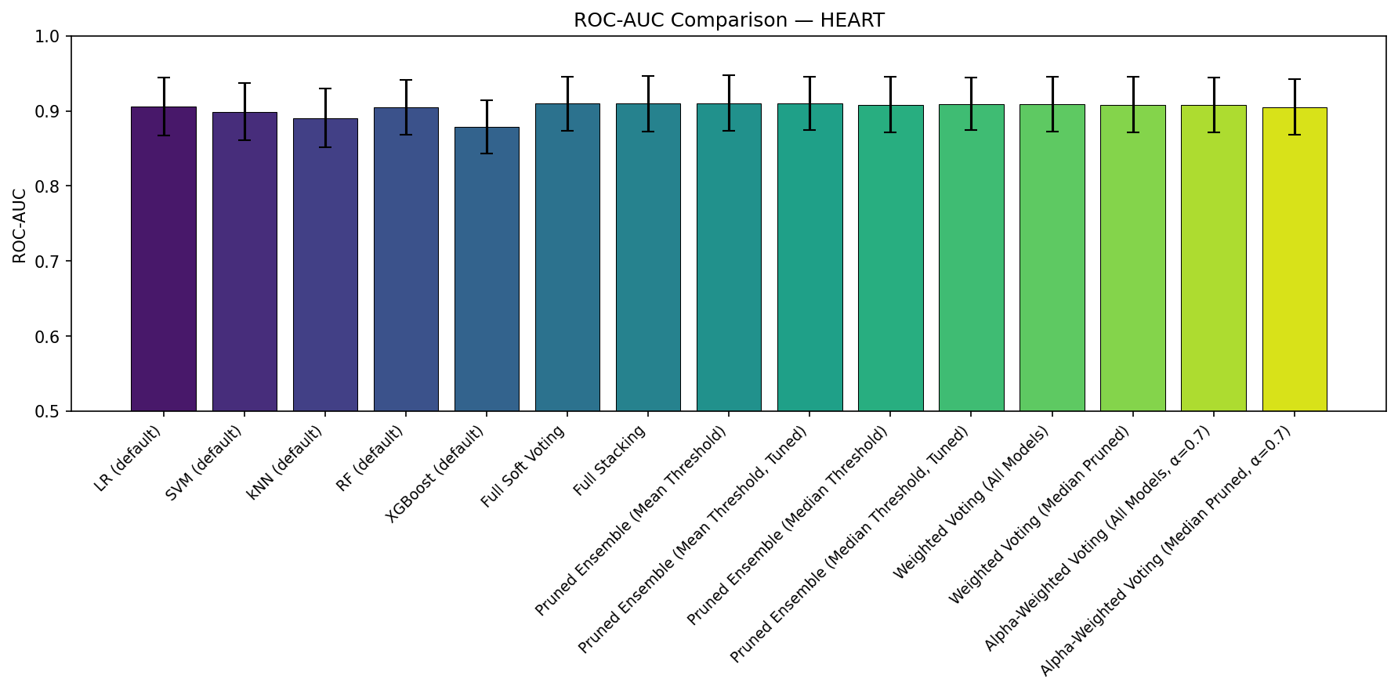
Figure 2. Mean ROC-AUC (with standard deviation error bars) for all evaluated methods on Heart Disease.
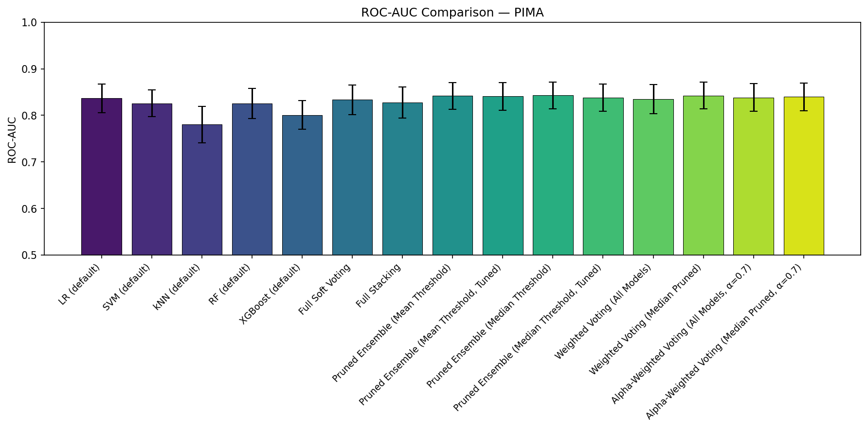
Figure 3. Mean ROC-AUC (with standard deviation error bars) for all evaluated methods on Pima Diabetes.
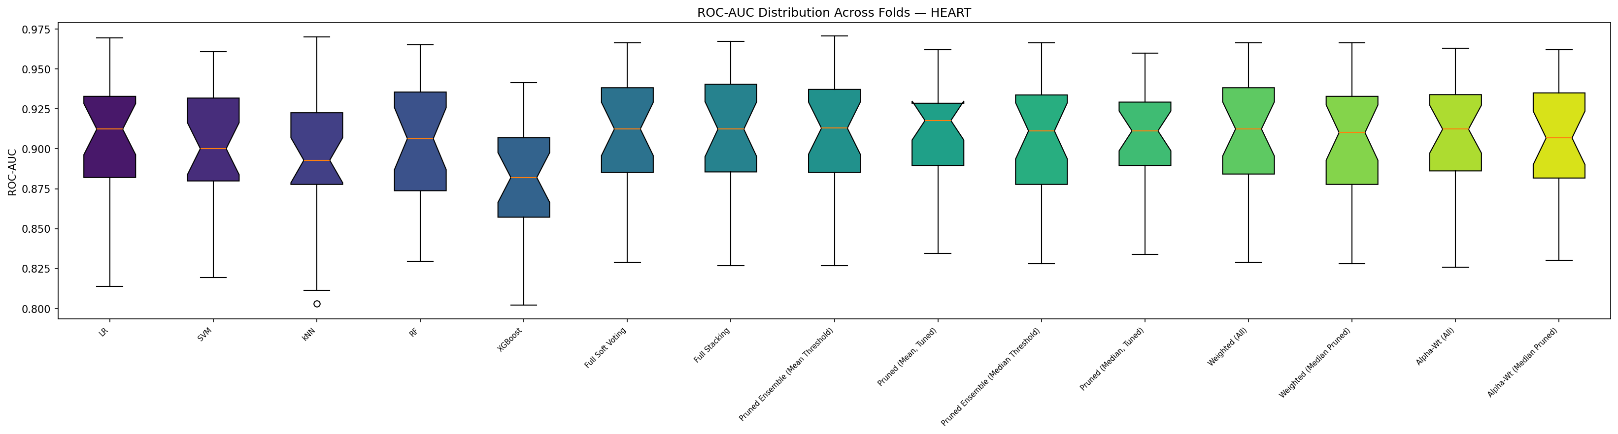
Figure 4. Fold-level AUC distributions on Heart Disease. Pruned variants are tighter and shifted slightly upward relative to full ensembles.
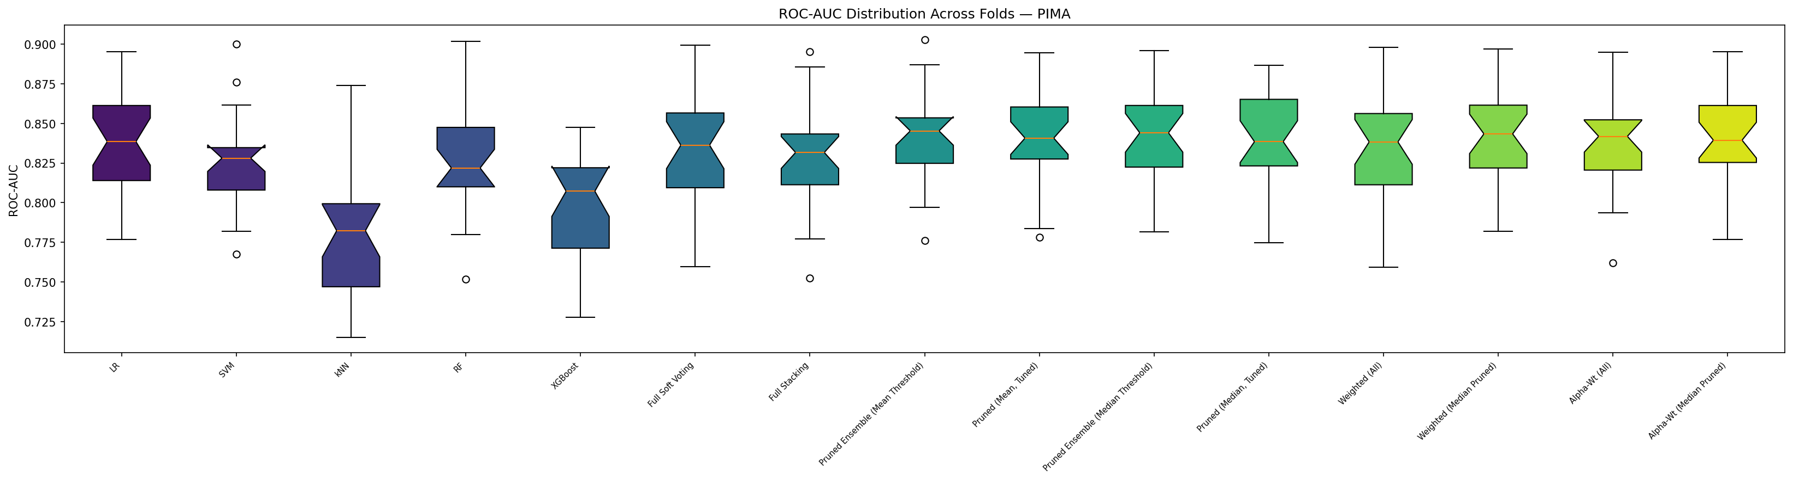
Figure 5. Fold-level AUC distributions on Pima Diabetes. The pruned ensembles clearly sit above the full soft-voting and stacking baselines.
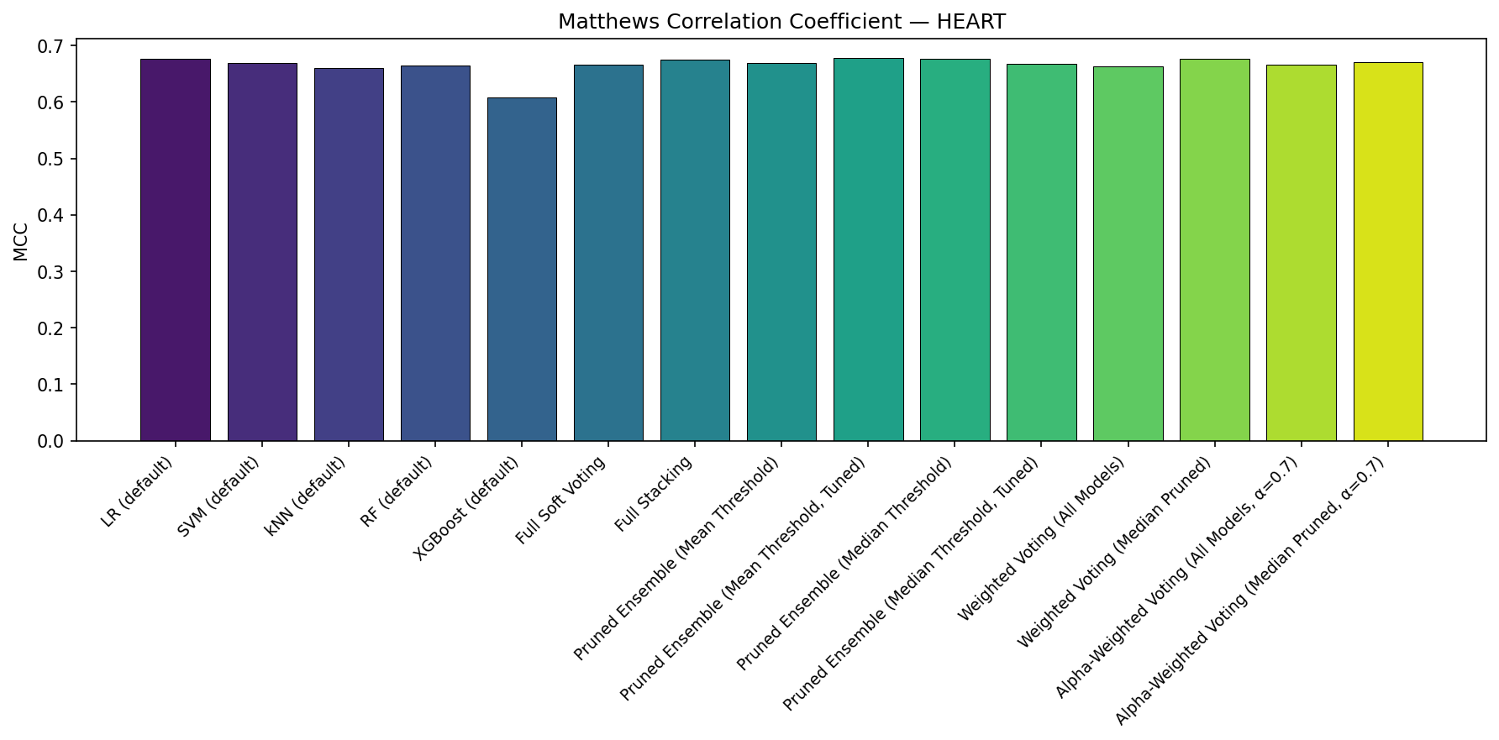
Figure 6. Mean MCC comparison on Heart Disease. MCC rewards balanced precision/recall and is useful for medical decision-making.
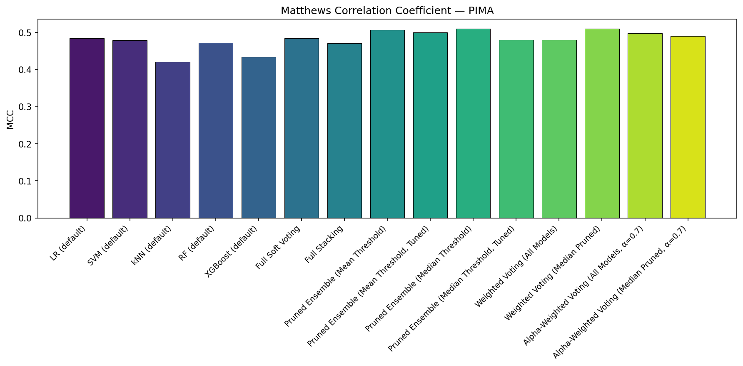
Figure 7. Mean MCC comparison on Pima Diabetes. The pruned and median-pruned weighted-voting methods dominate the field.
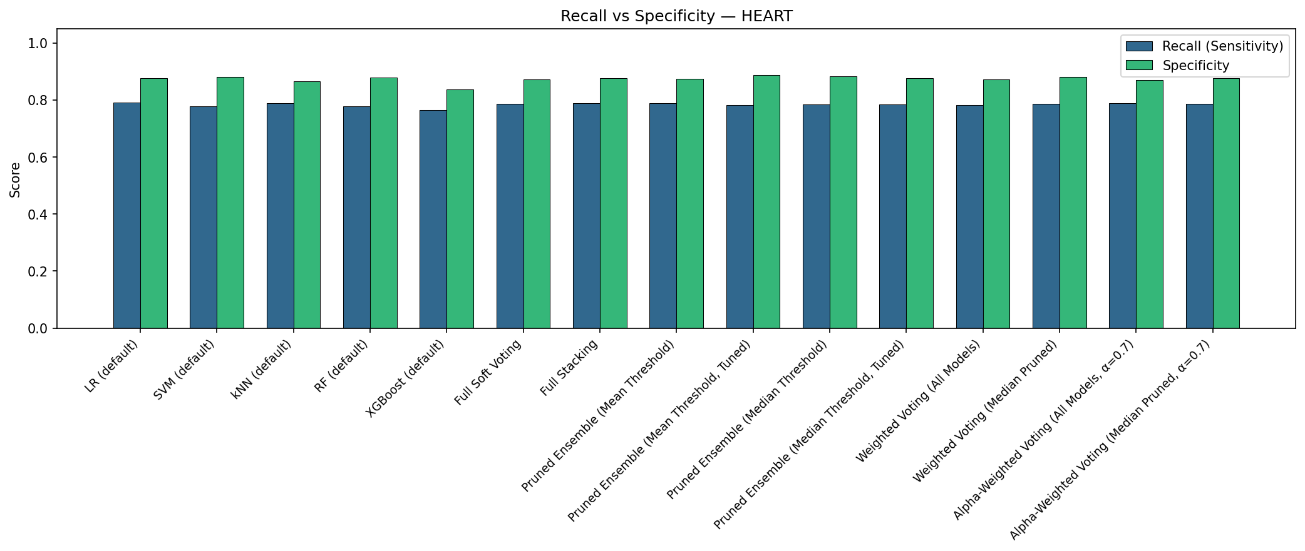
Figure 8. Recall vs. Specificity tradeoff on Heart Disease.
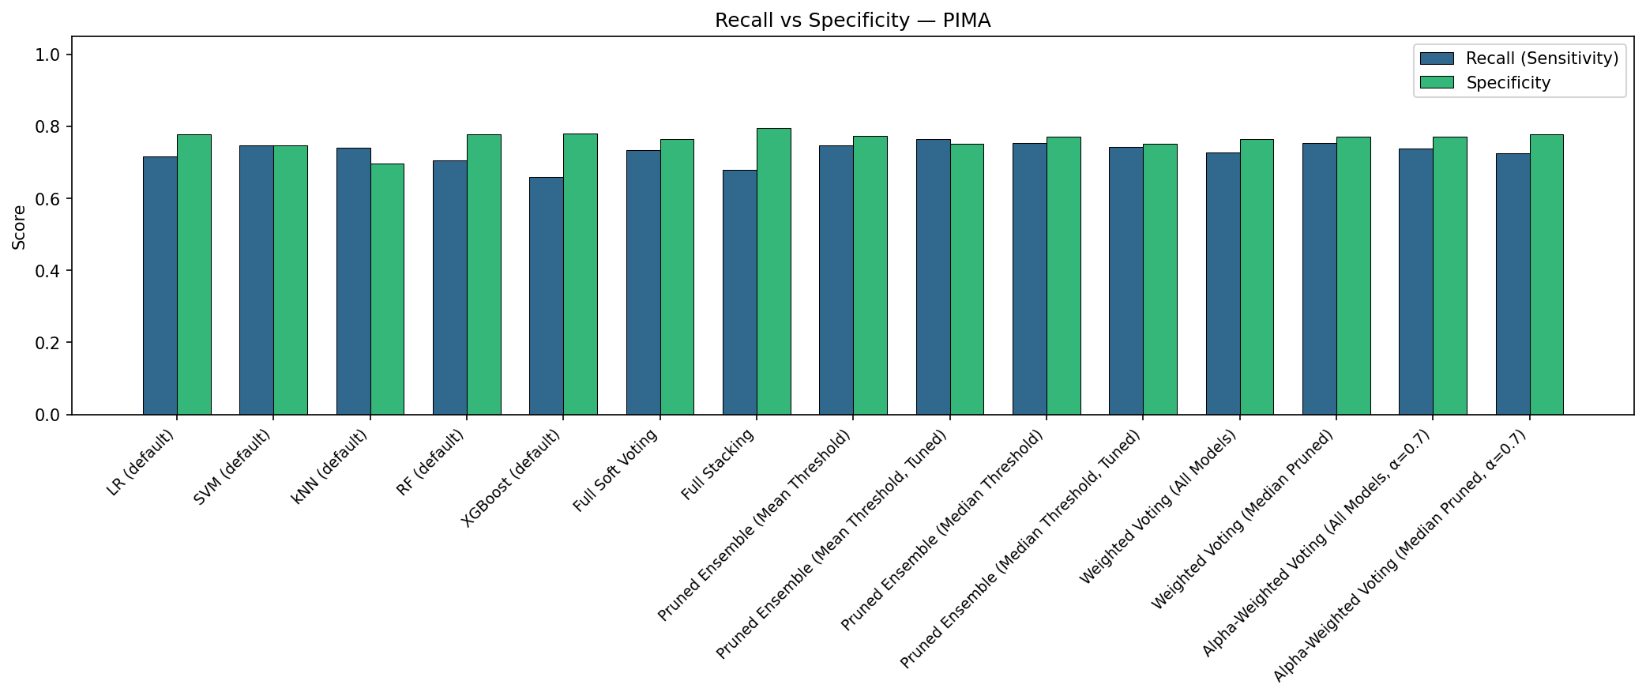
Figure 9. Recall vs. Specificity tradeoff on Pima Diabetes.

4.4 Stage 4 — Hyperparameter Tuning
Hyperparameter tuning after pruning produced small and direction-dependent changes. On Heart Disease, tuning improved the MCC of the mean-pruned ensemble from 0.6689 to 0.6783 and raised accuracy to 0.8388, while slightly reducing recall; this is consistent with a marginal shift toward higher-specificity decisions. On Pima Diabetes, tuning the mean-pruned ensemble increased recall from 0.7478 to 0.7657 but reduced specificity and overall accuracy, ending with a very similar AUC (0.8407 vs. 0.8419) and a slightly lower MCC. Tuning the median-pruned ensemble actually hurt performance on Pima, dropping MCC from 0.5101 to 0.4799 — a reminder that grid search on a small dataset with only a 3-fold inner CV can easily overfit the tuning fold and return hyperparameters that do not generalize.

4.5 Answering the Research Questions
RQ1 (Does pruning help?). Yes, and the effect is largest on the harder dataset. On Pima, the pruned ensembles (mean and median) beat both full soft voting and full stacking on accuracy, AUC, F1, and MCC. On Heart, the pruned and full ensembles converge to the same AUC but pruning wins on simplicity and, for the tuned mean variant, on MCC.
RQ2 (Mean vs. median thresholding?). The two strategies are very close. On Heart the mean-threshold pruned ensemble has a slightly higher AUC, while on Pima the median-threshold variant is marginally ahead. Because the median is more robust to extreme base-model values, it is the preferable default when the classifier pool includes outliers — which was the case on Pima where kNN was a clear underperformer.
RQ3 (Weighted vs. simple pruning?). On Pima, weighted voting over the median-pruned subset achieves the highest MCC in the entire table (0.5105), edging out unweighted median-pruned voting by a negligible margin. On Heart the weighted and unweighted variants are statistically indistinguishable. Explicit stability weights therefore offer a small additional benefit when they are applied after pruning — applying them to the full pool (including weak models) does not help.
RQ4 (Does post-pruning tuning add value?). On Heart, tuning the mean-pruned ensemble gives a small but consistent boost in MCC. On Pima, tuning’s effect is ambiguous and can be negative, especially for the median-pruned ensemble. This suggests that on very small and imbalanced datasets the gain from tuning is limited by the noise of the inner CV fold and that pruning itself captures most of the available improvement.

5. Conclusion
This project implemented and evaluated a complete machine learning pipeline for binary medical classification on the UCI Heart Disease and Pima Indians Diabetes datasets. Starting from five heterogeneous base classifiers, we computed stability scores from 5×5 repeated stratified cross-validation and used them to prune the ensemble using two thresholding strategies, then compared the pruned ensembles to full soft-voting, full stacking, stability-weighted voting, and an α-weighted performance/stability tradeoff. Hyperparameter tuning was deliberately applied after pruning to avoid bias.
The main finding is that stability-guided pruning is a simple, effective, and interpretable way to build ensembles on small medical datasets. On Pima Diabetes, pruning raised ROC-AUC by roughly 1 point and MCC by nearly 3 points relative to the full soft-voting baseline and outperformed full stacking on every metric except specificity. On Heart Disease, pruning matched the best full-ensemble AUC while using only three base classifiers, yielding a more compact and lower-variance model. Weighted voting over the pruned subset provides a further marginal gain on Pima and is recommended as a default strategy when stability scores are available. Hyperparameter tuning after pruning delivered inconsistent improvements and should be treated as optional, especially on very small datasets.
Several limitations should be kept in mind when interpreting these results. Both datasets are small, which makes all differences of less than roughly 0.01 in AUC statistically uncertain despite the 25-fold cross-validation. No statistical significance test (for example, a paired Wilcoxon signed-rank test across folds) was reported; adding one would strengthen the claims. The base classifier pool is limited to five models, and results might differ with a larger or more diverse pool, for which more aggressive pruning could be necessary. Finally, all tuning used a fixed 3-fold inner CV and a small hyperparameter grid, and the robustness of the tuned results to these choices has not been explored.
Future work could address these limitations by (i) adding statistical significance tests, (ii) extending the classifier pool and experimenting with stricter pruning thresholds, (iii) exploring alternative stability measures such as kappa-based agreement or bootstrap variance, and (iv) validating the approach on additional medical datasets with different characteristics (larger sample size, more features, multi-class labels).

